**Week 5**

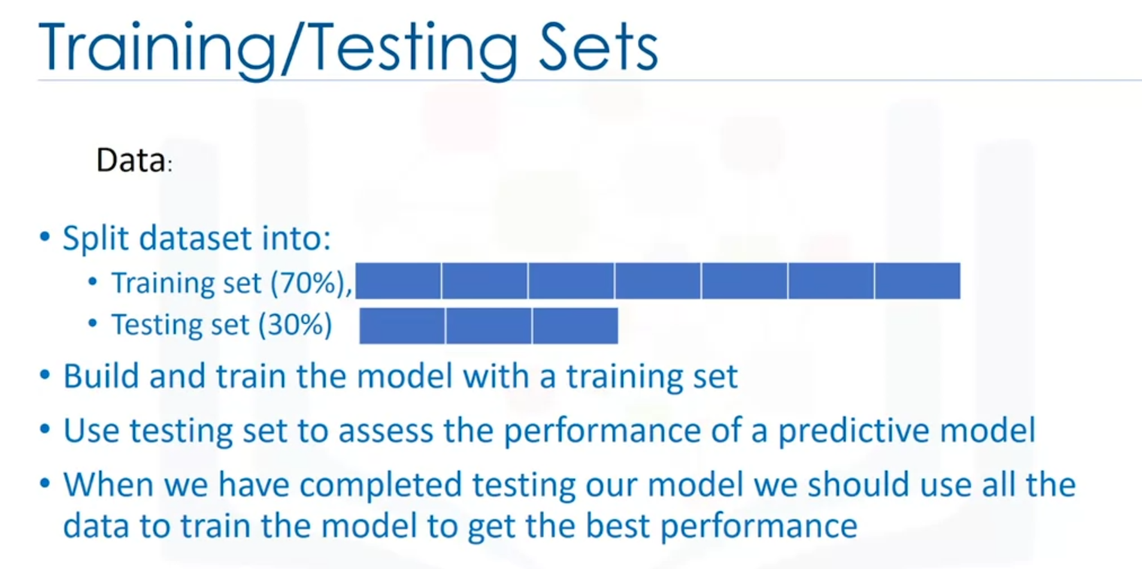

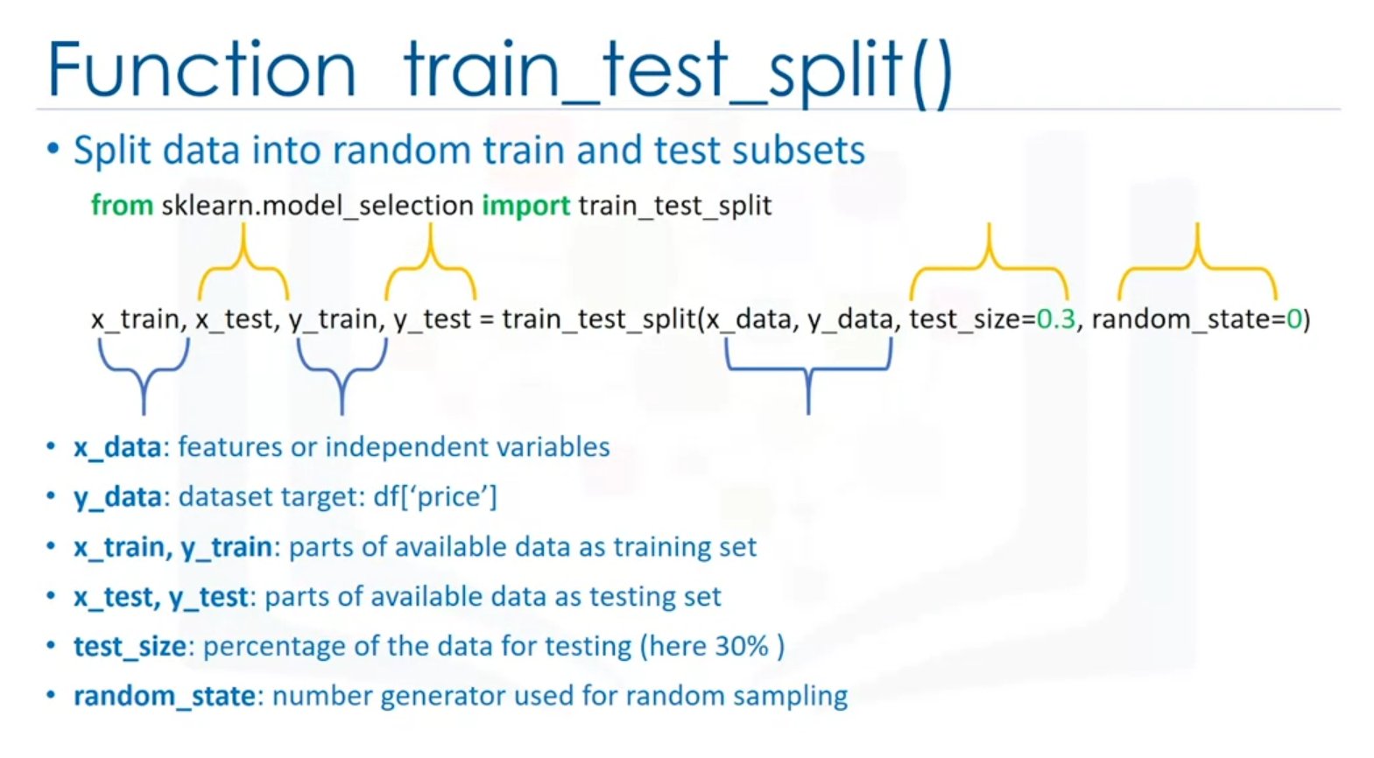

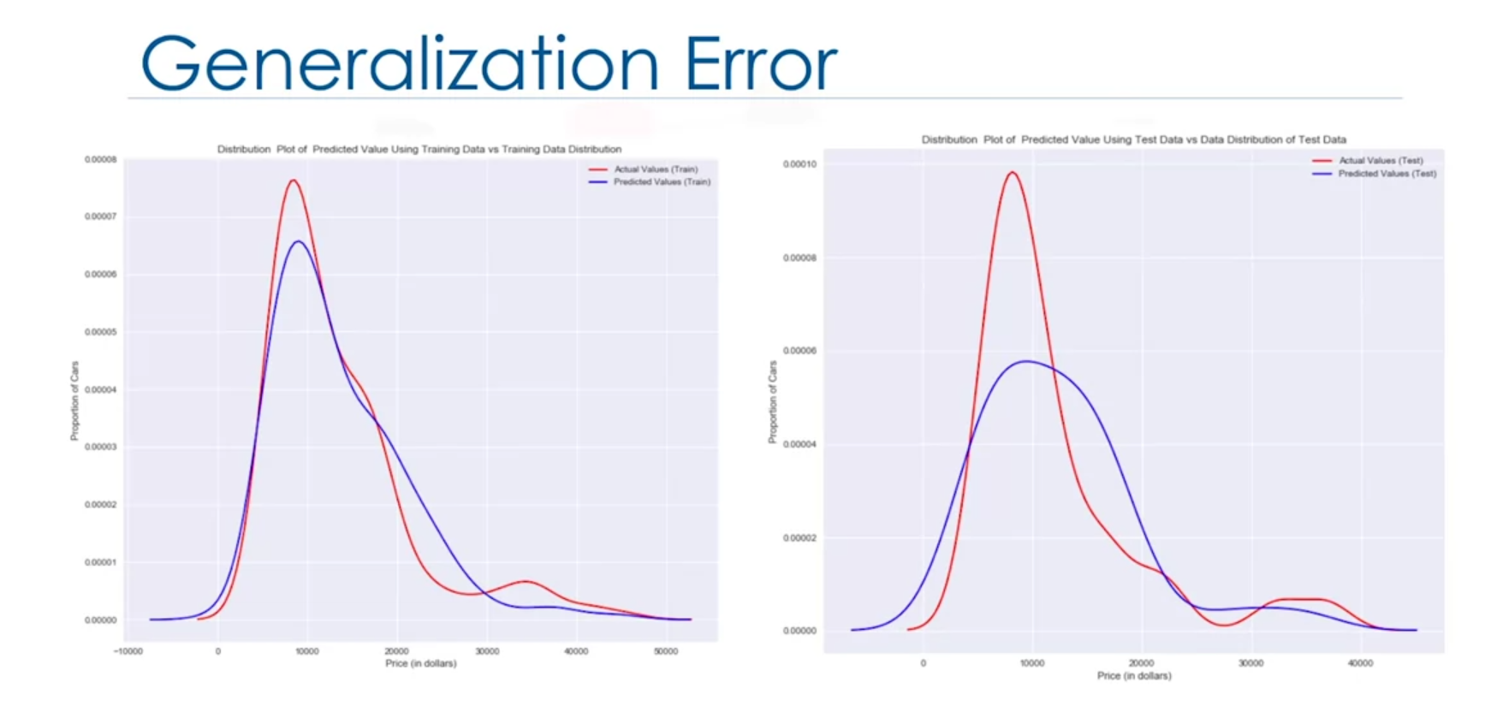

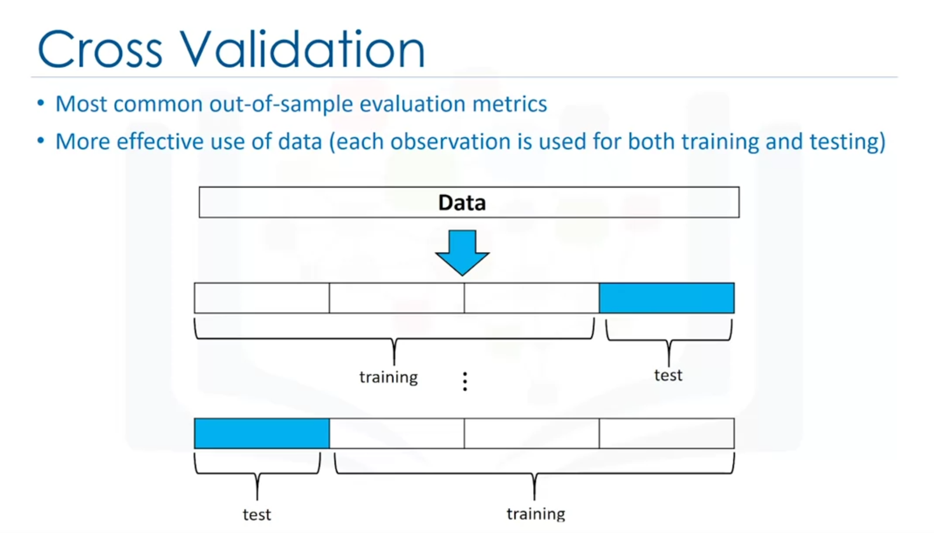

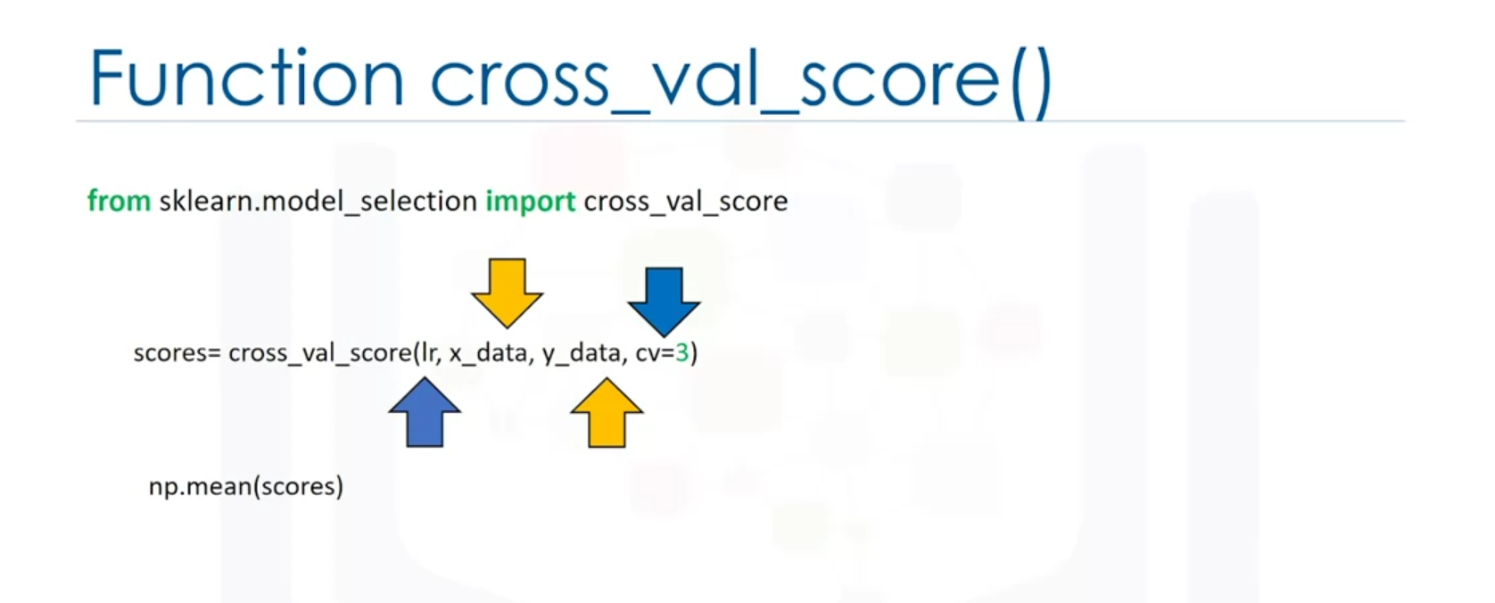

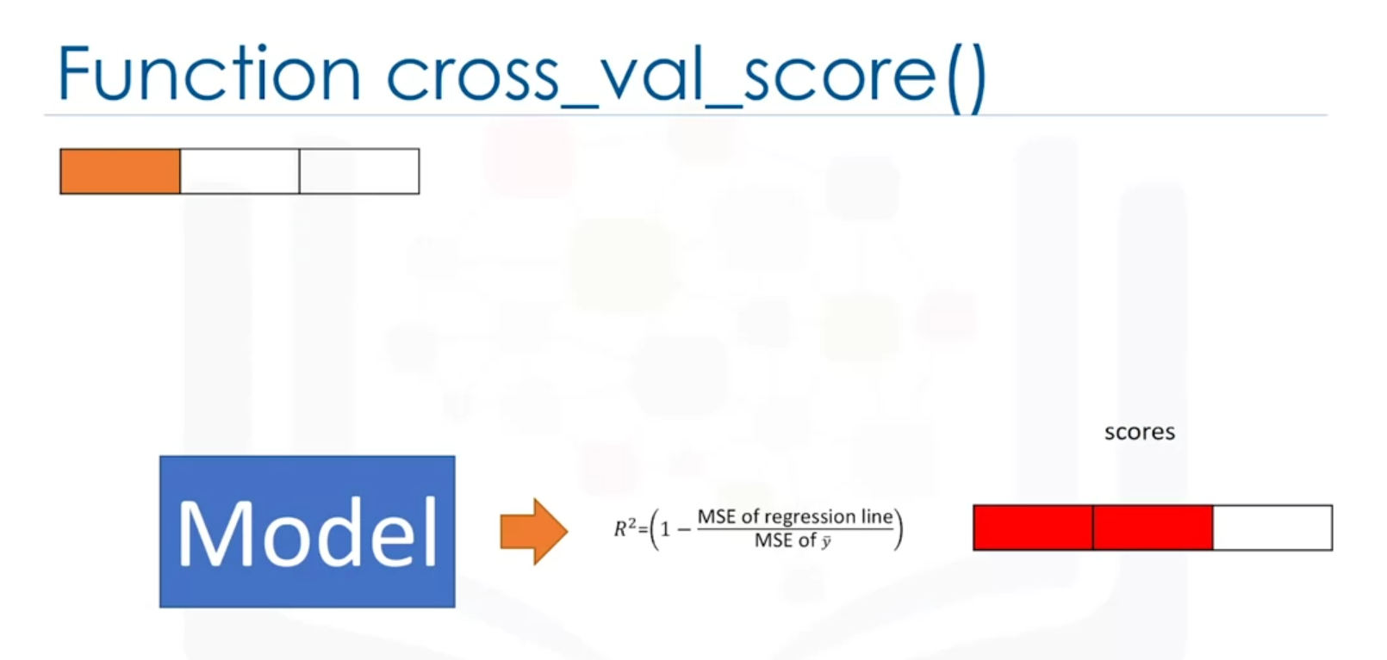

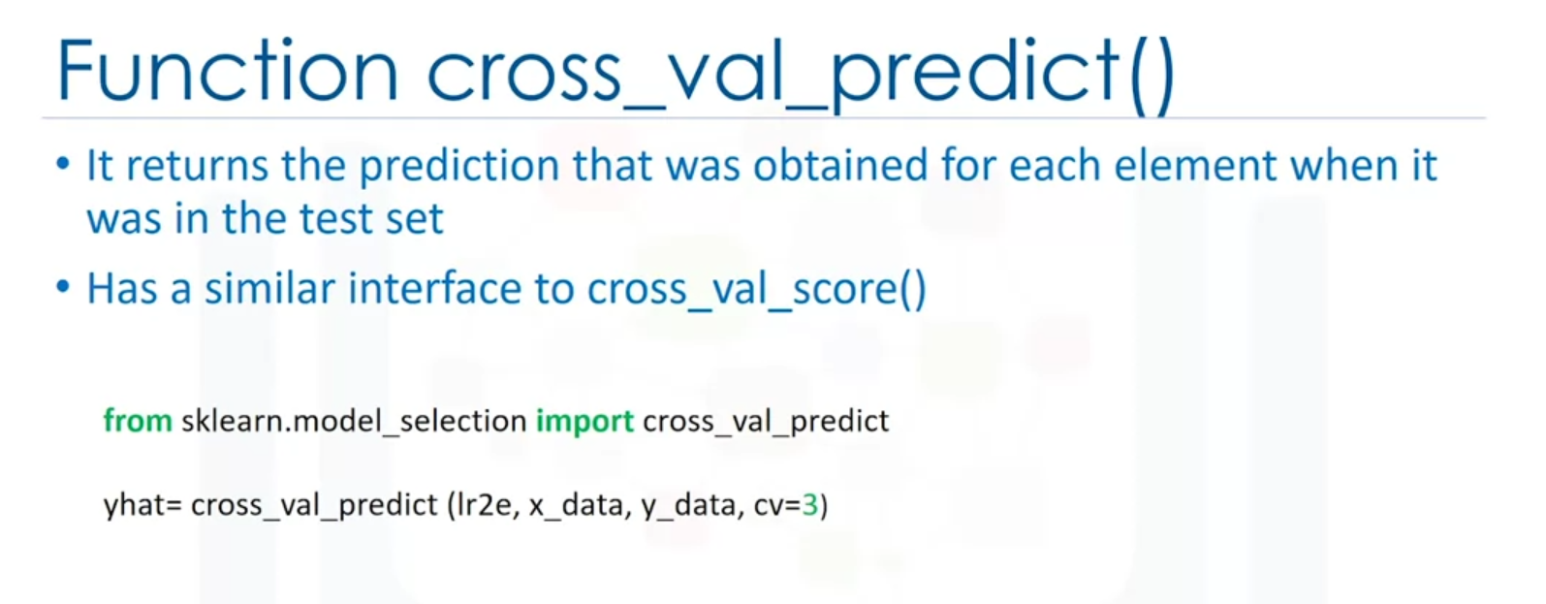

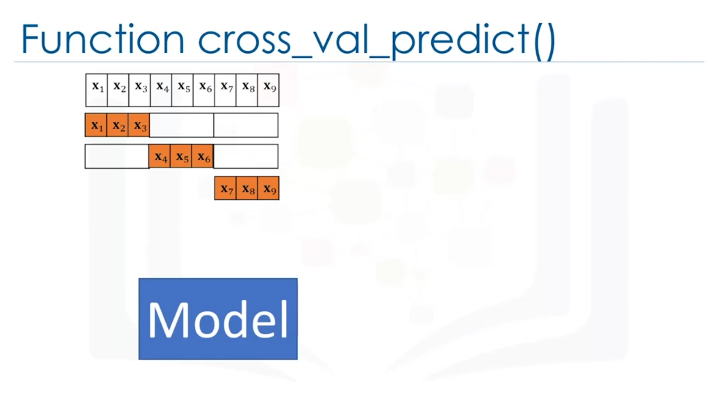

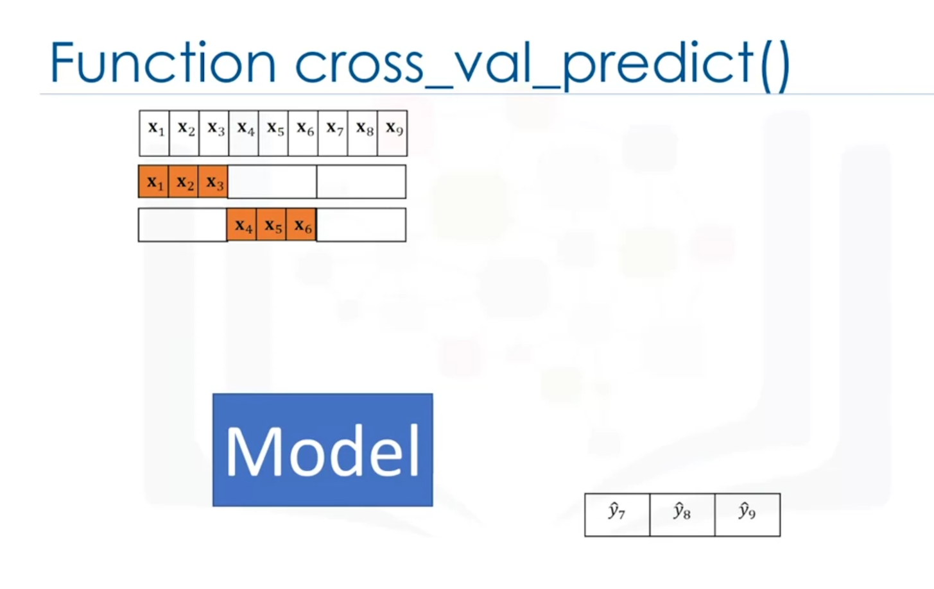

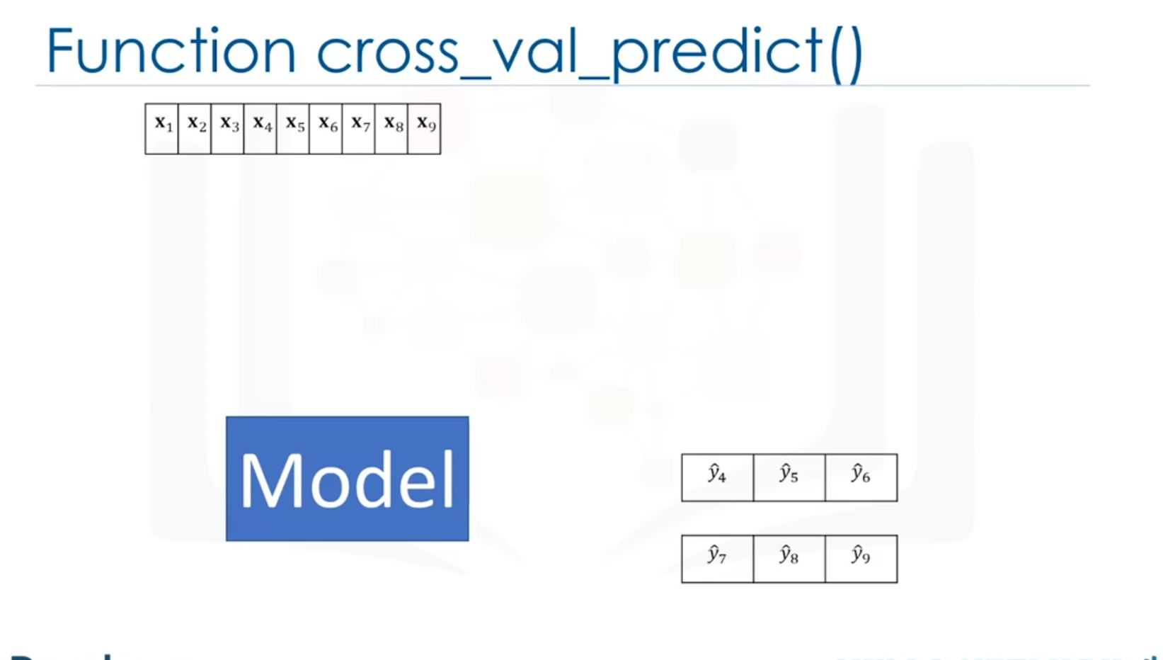

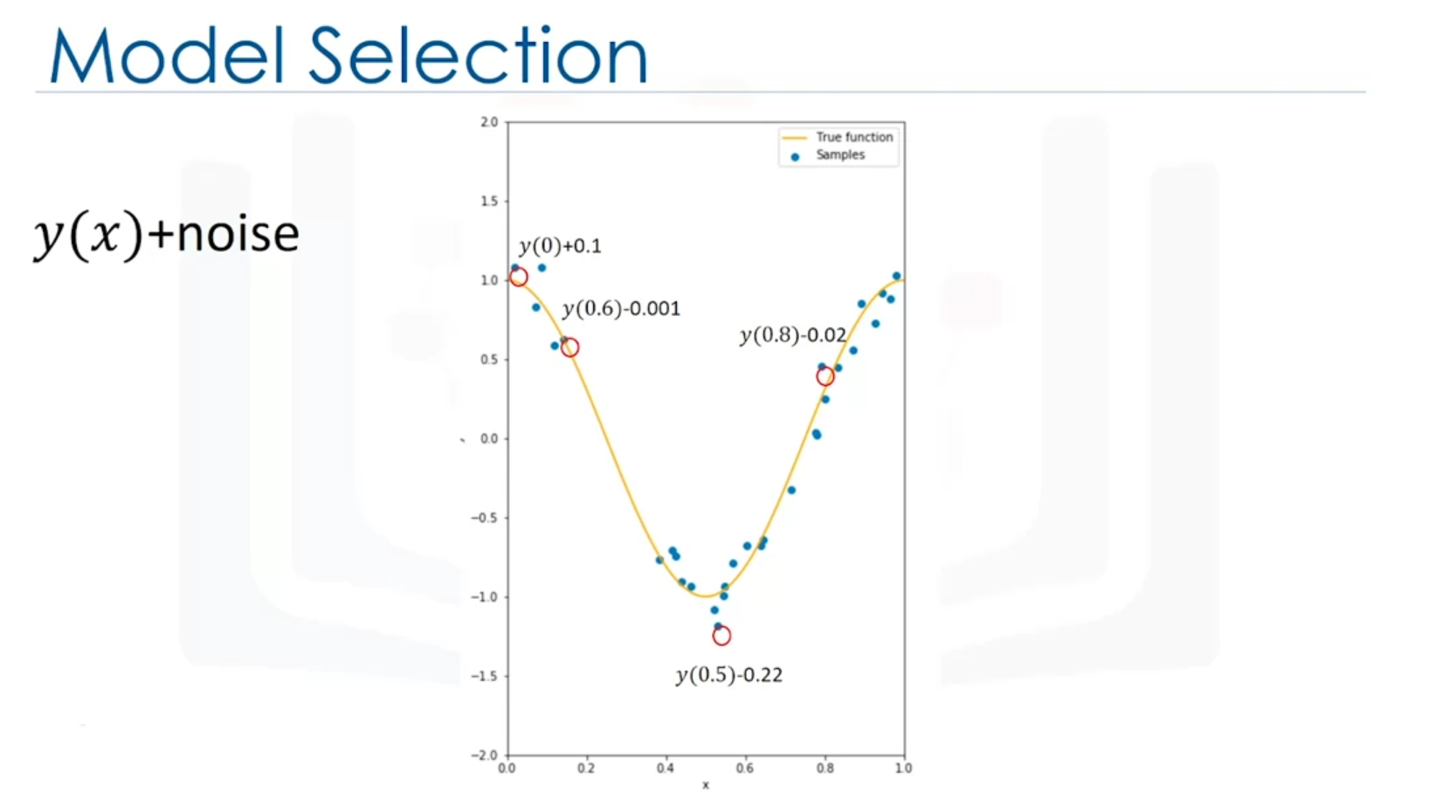

Many errors = underfitting.

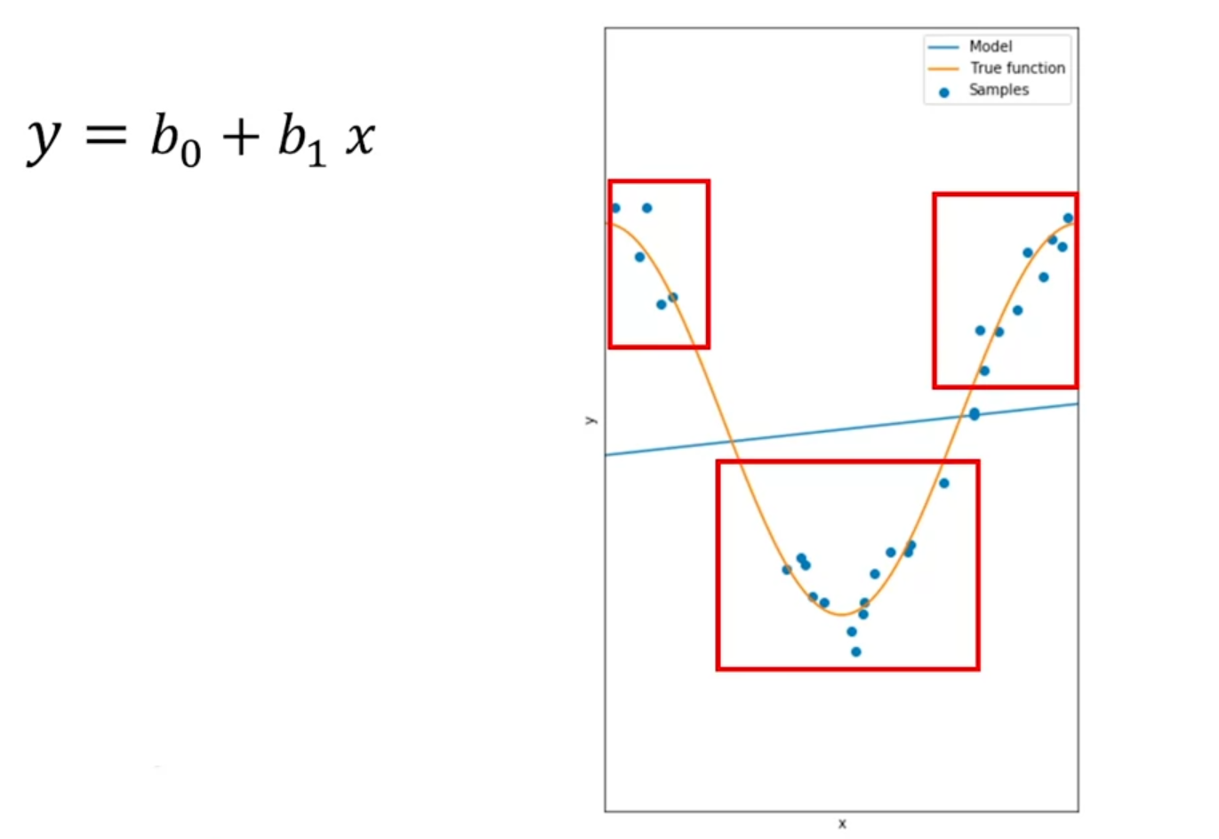

Still not flexible enough, underfitting:

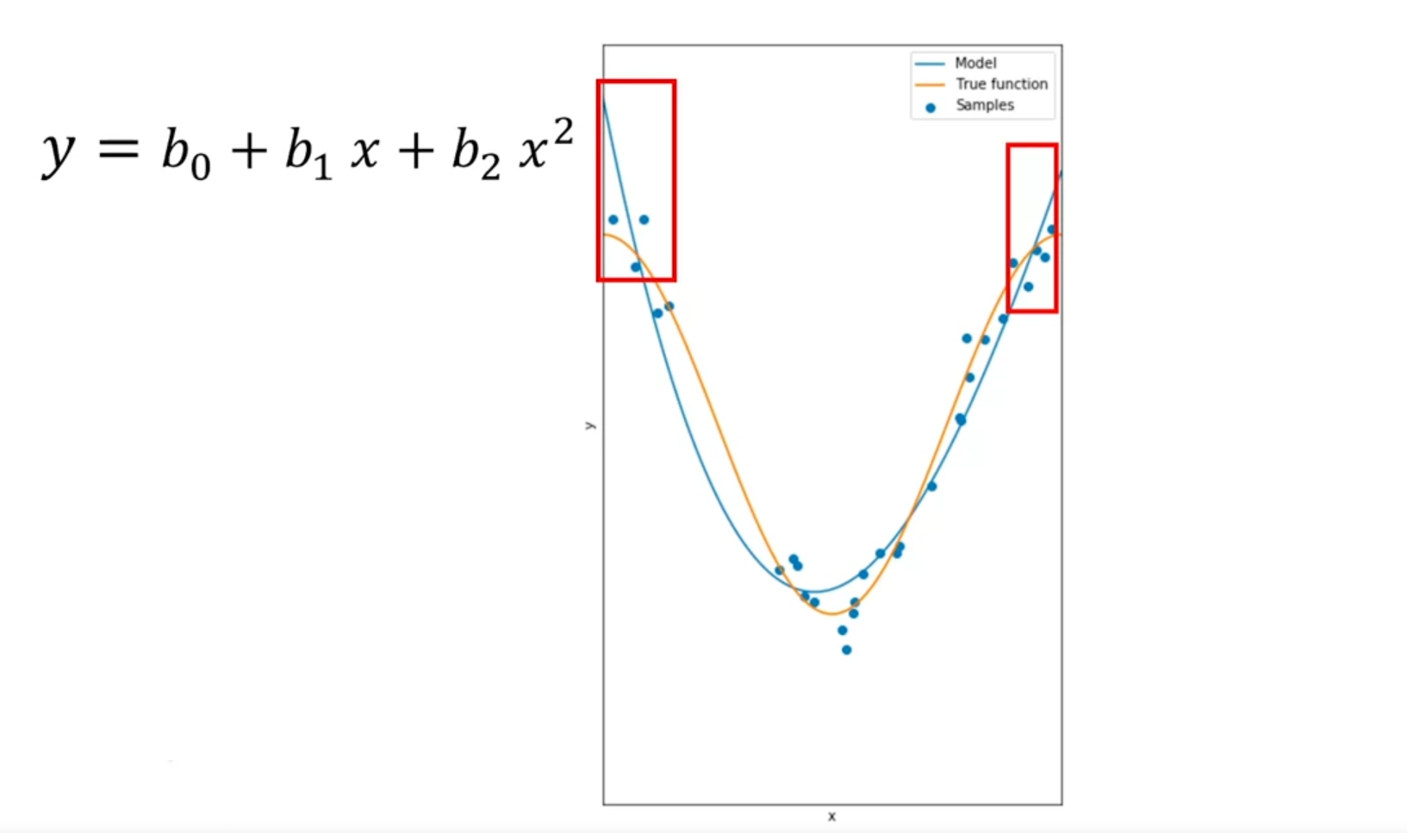

Poor performance of the model = overfitting; the function fits the noise rather than the function:

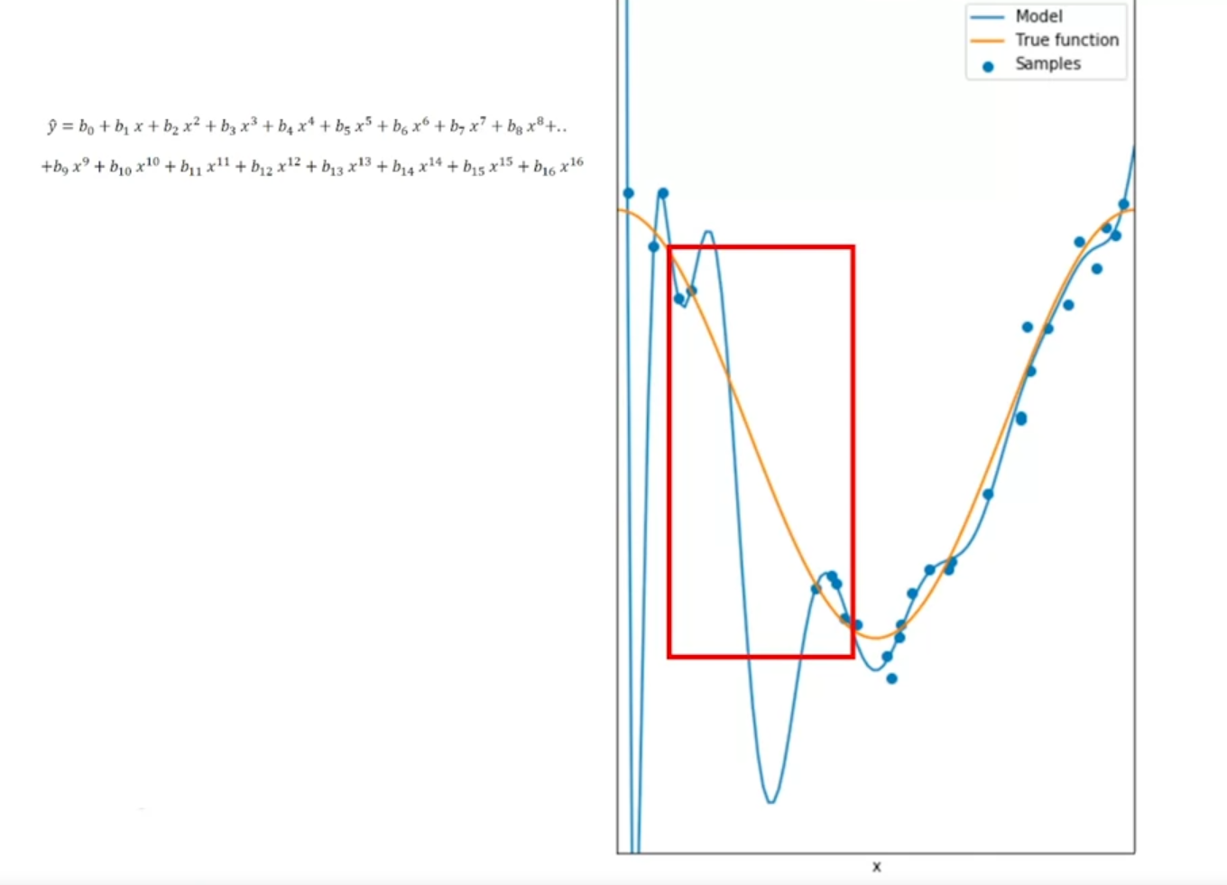

Left or right = underfitting or overfitting:

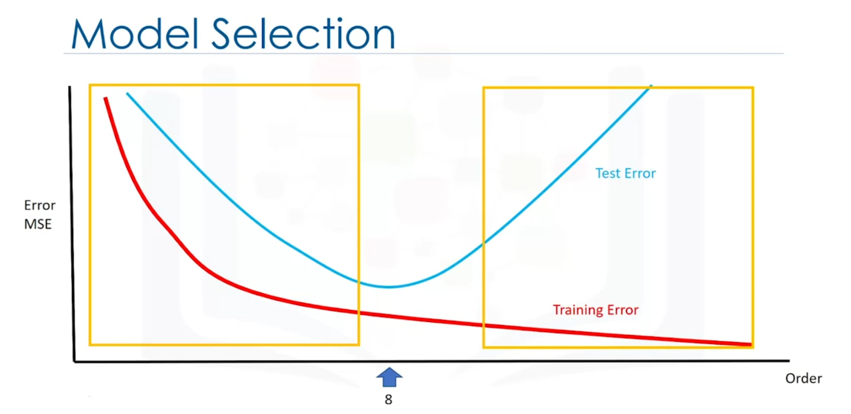

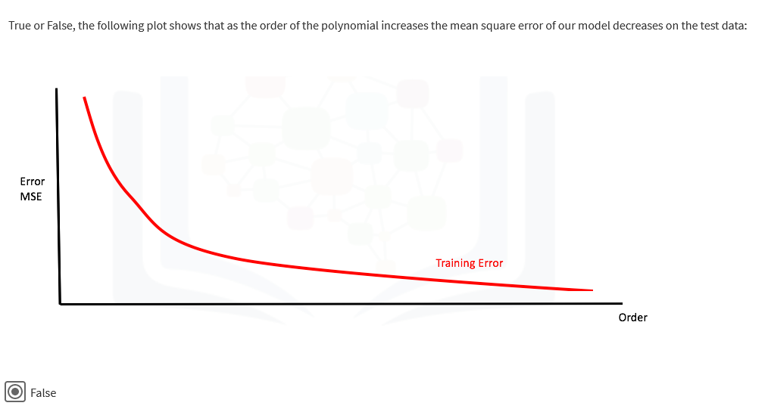

Optimal R^2:

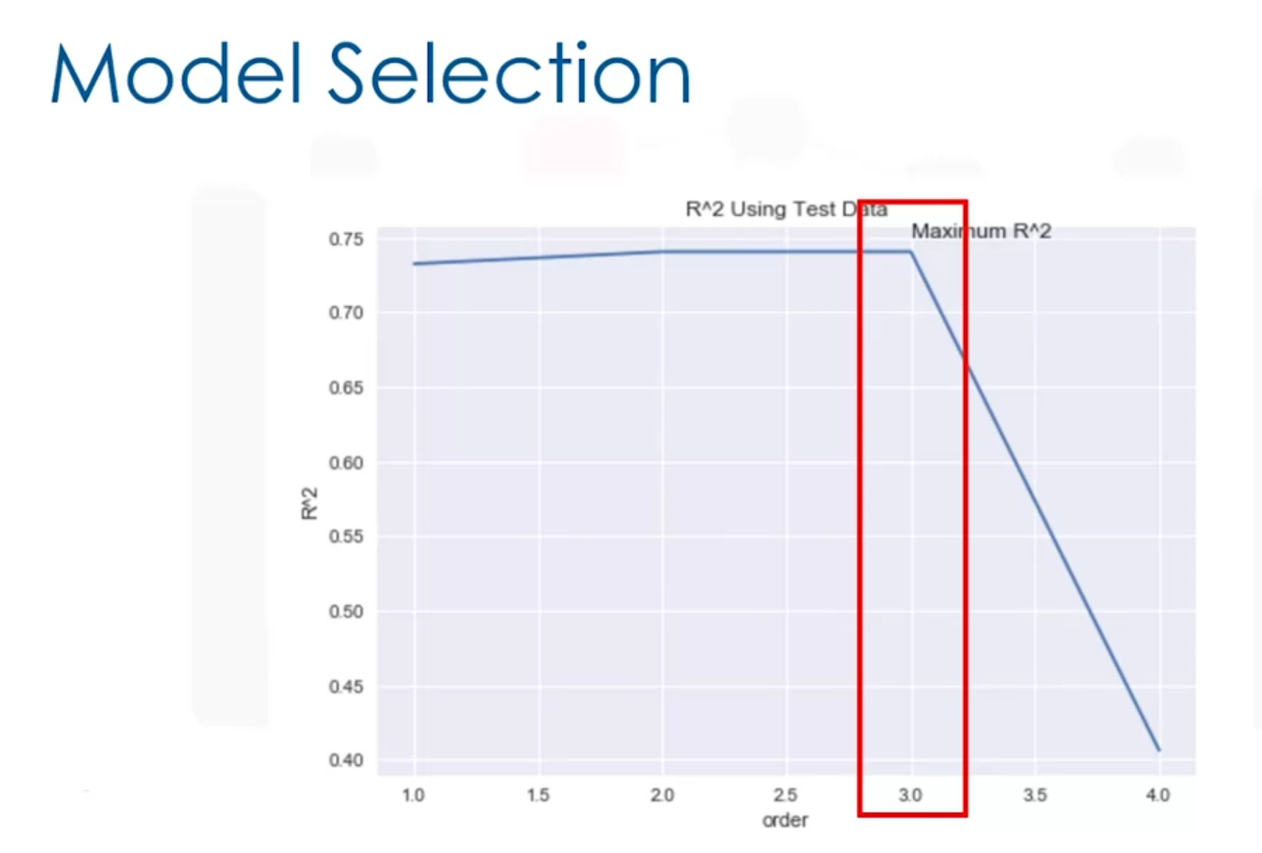

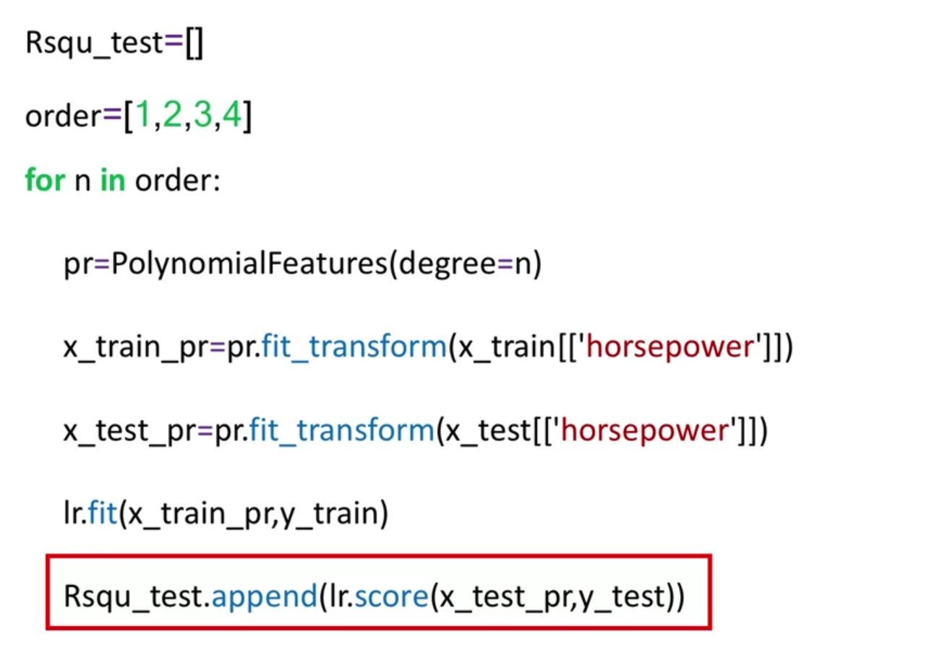

# Ridge Regression Introduction

Ridge regression is a regression that is employed in a Multiple regression model when Multicollinearity occurs. Multicollinearity is when there is a strong relationship among the independent variables. Ridge regression is very common with polynomial regression. The next video shows how Ridge regression is used to regularize and reduce the standard errors to avoid over-fitting a regression model

Outlier:

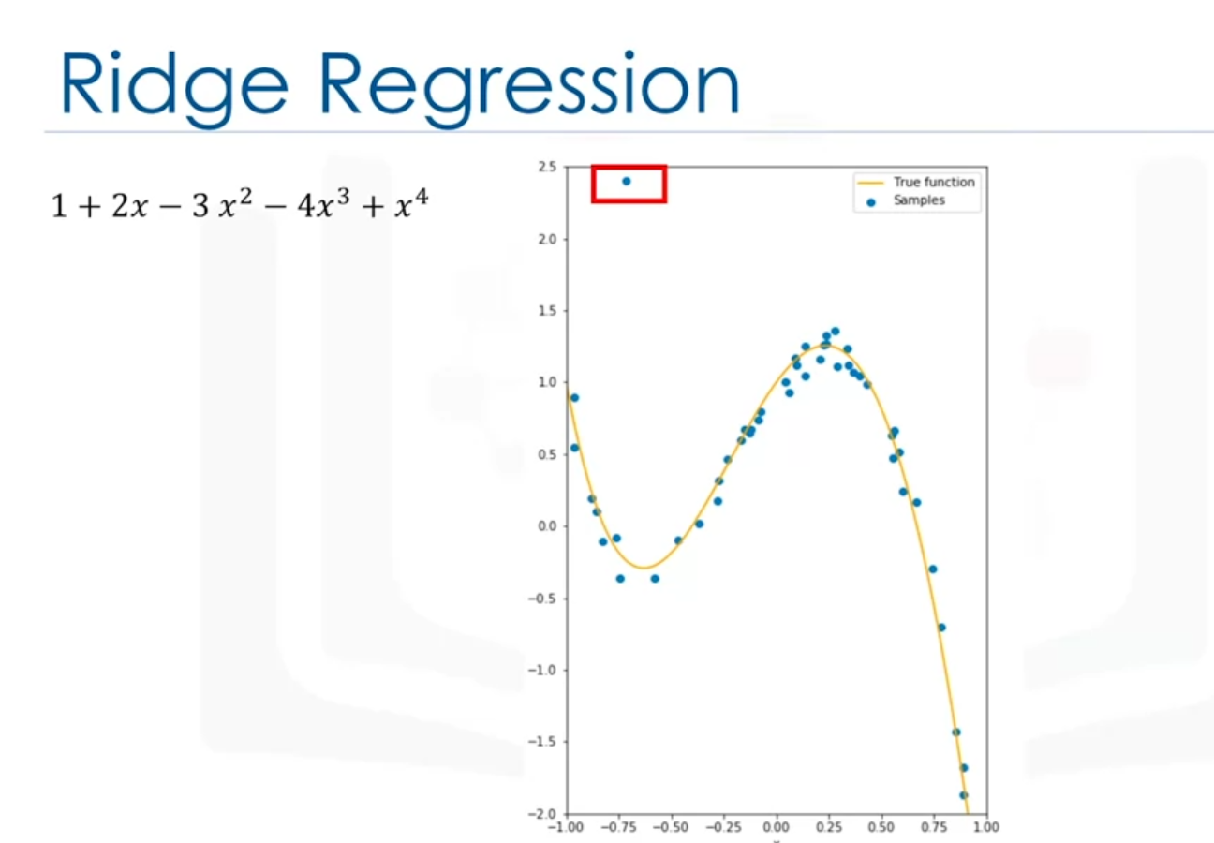

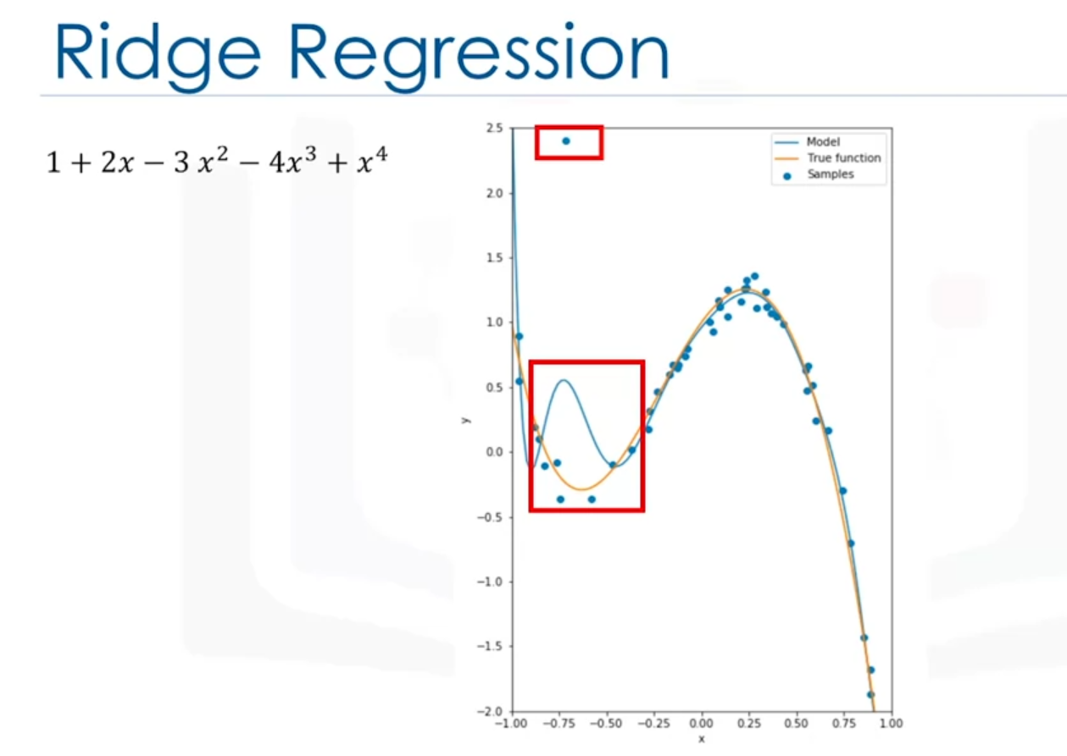

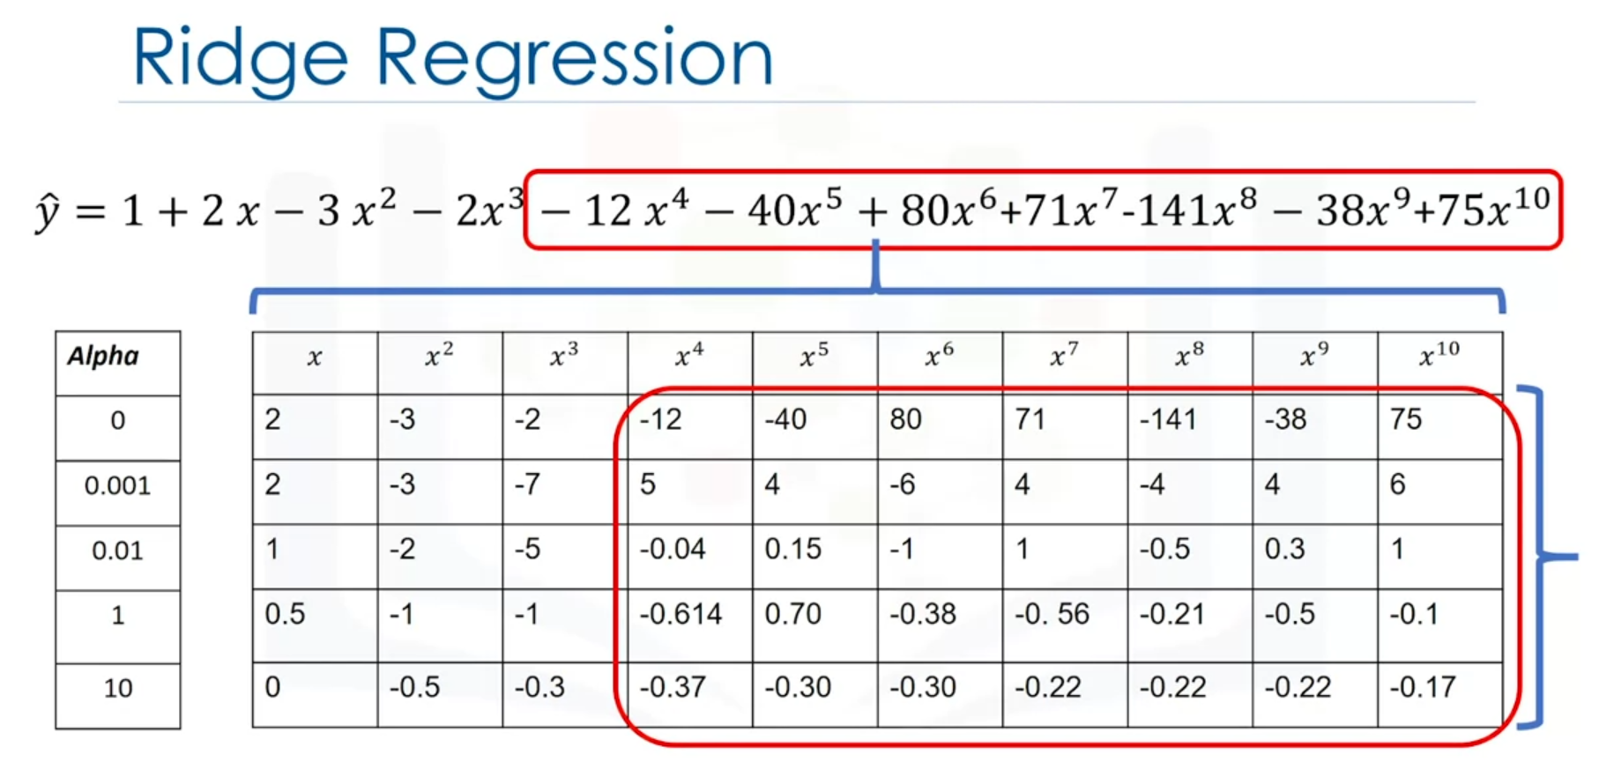

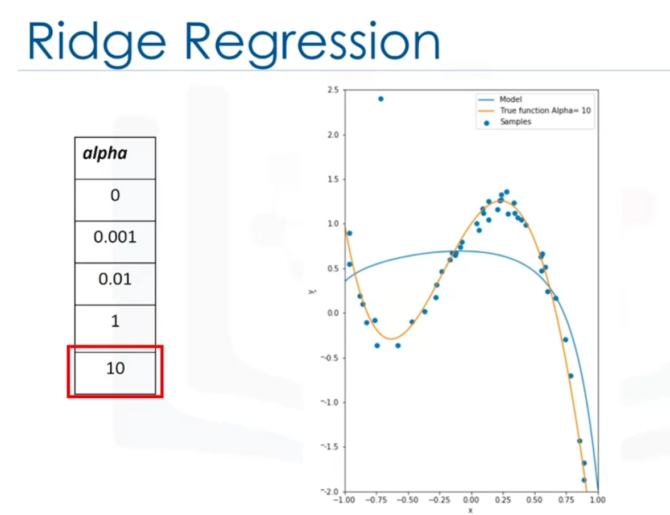

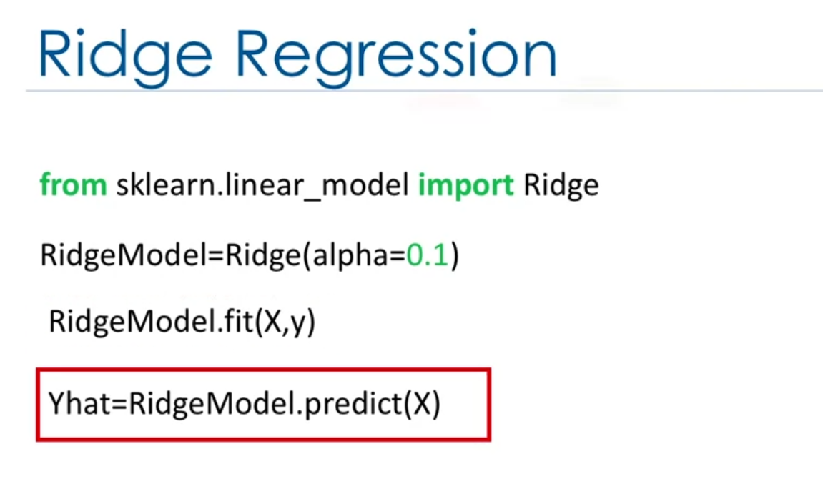

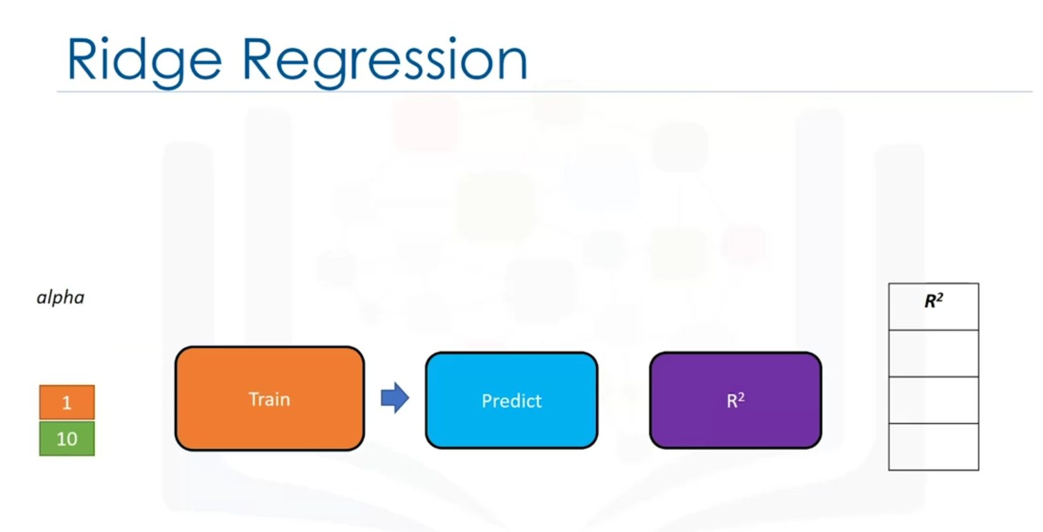

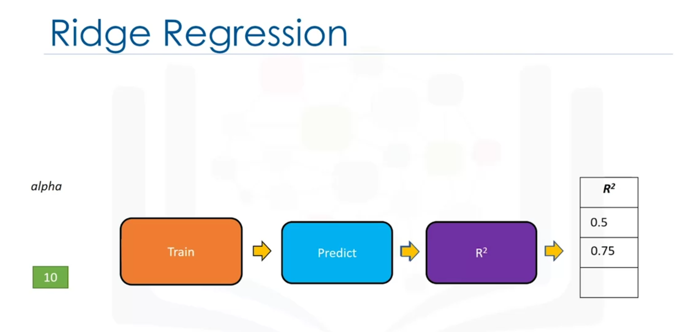

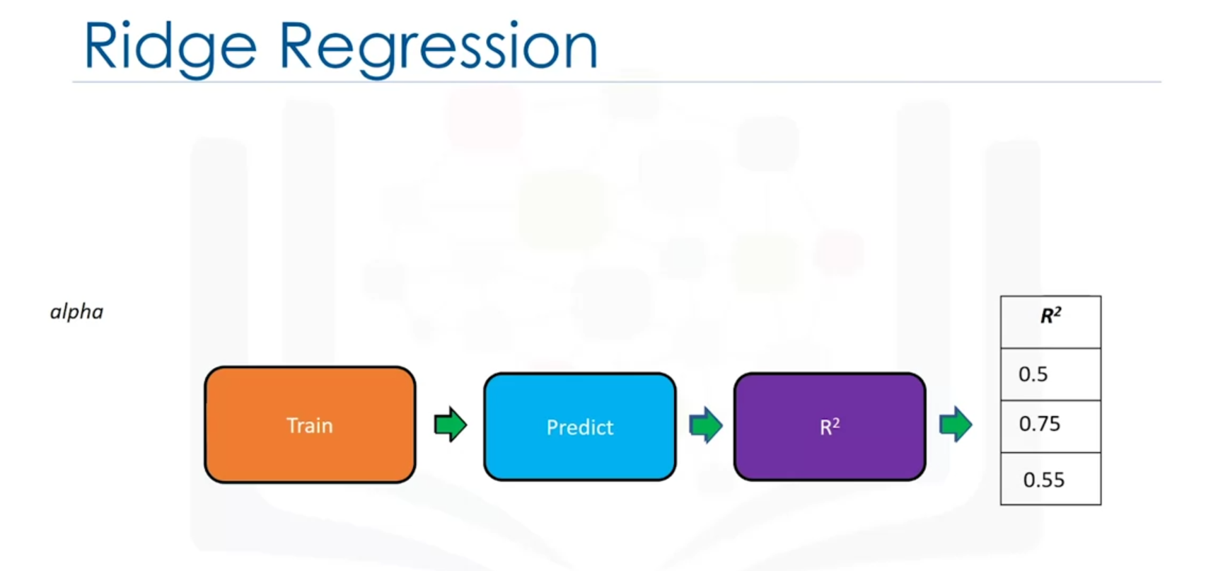

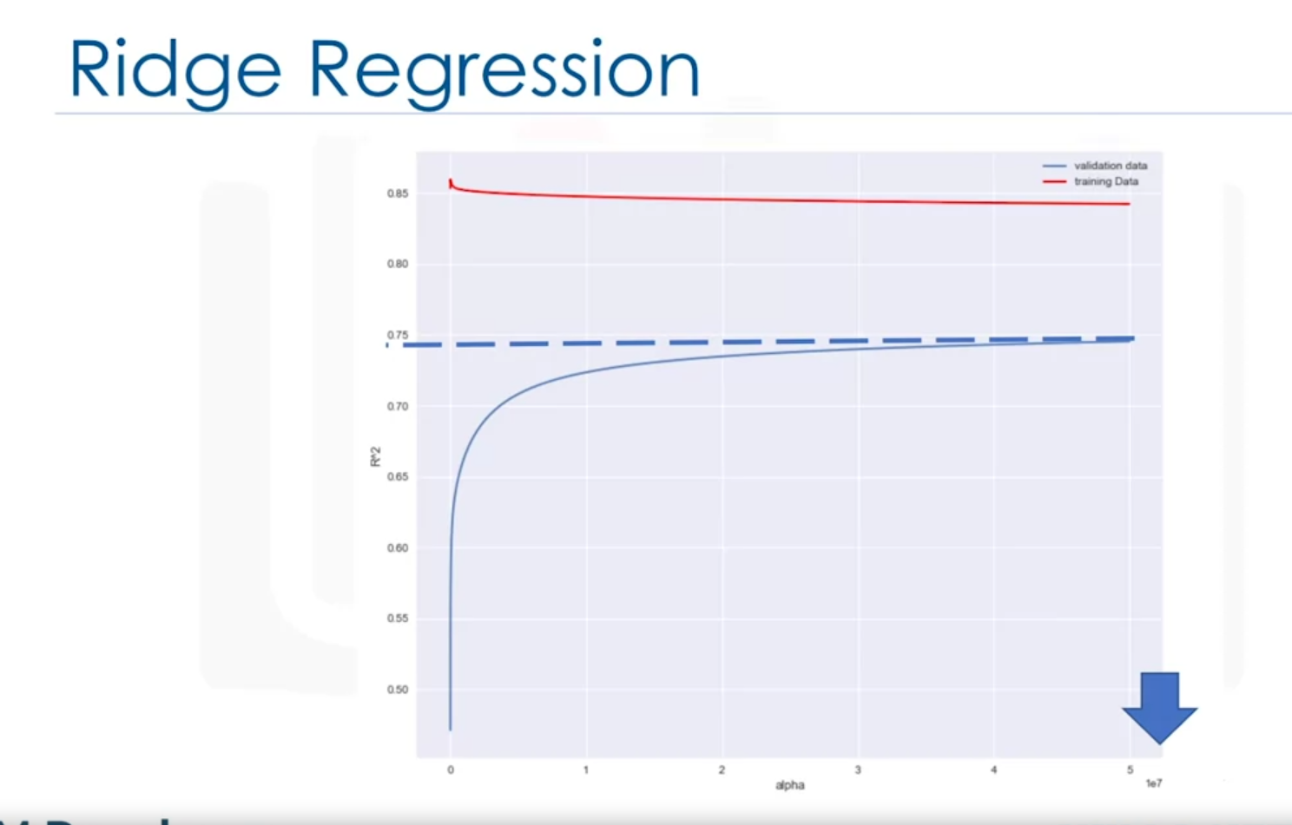

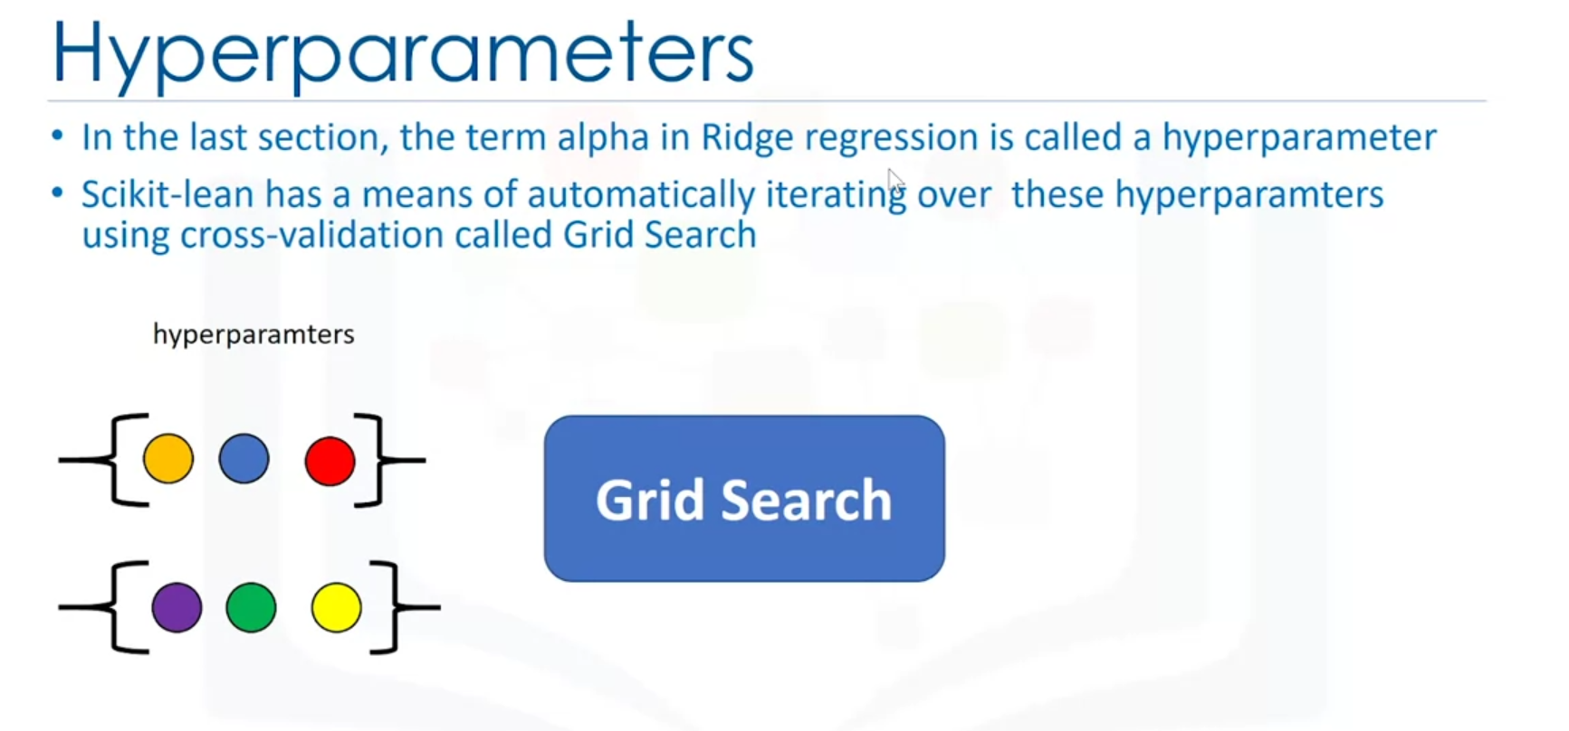

Train the model:

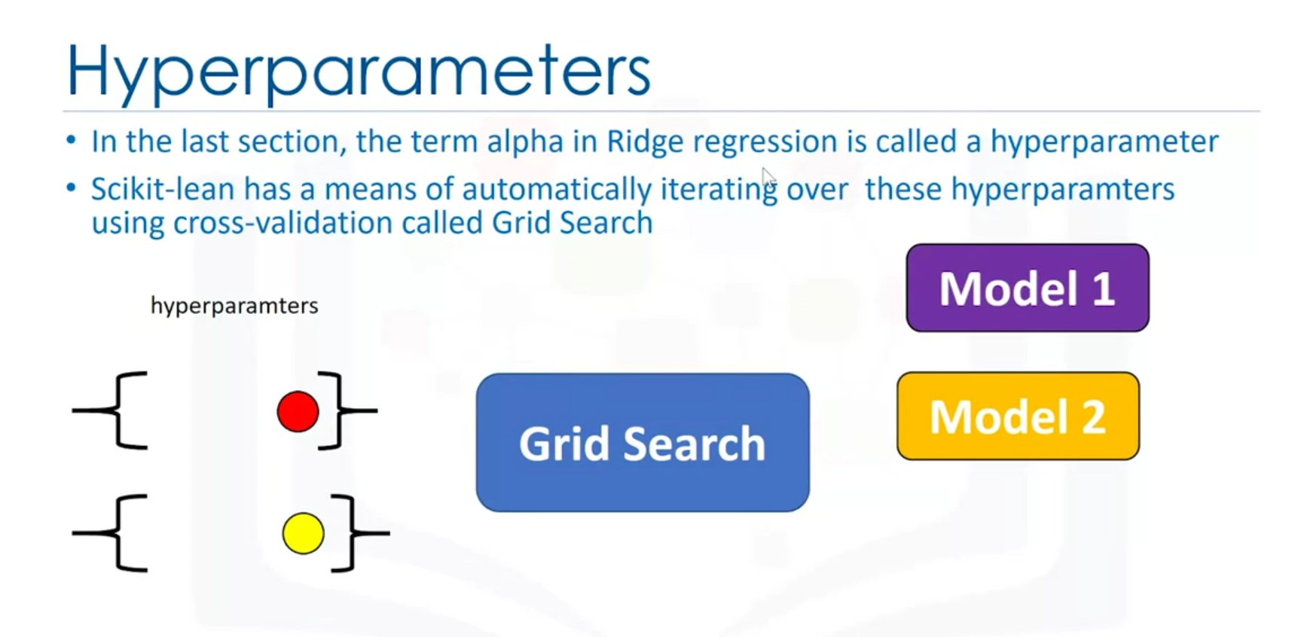

Select the model that minimizes the error:

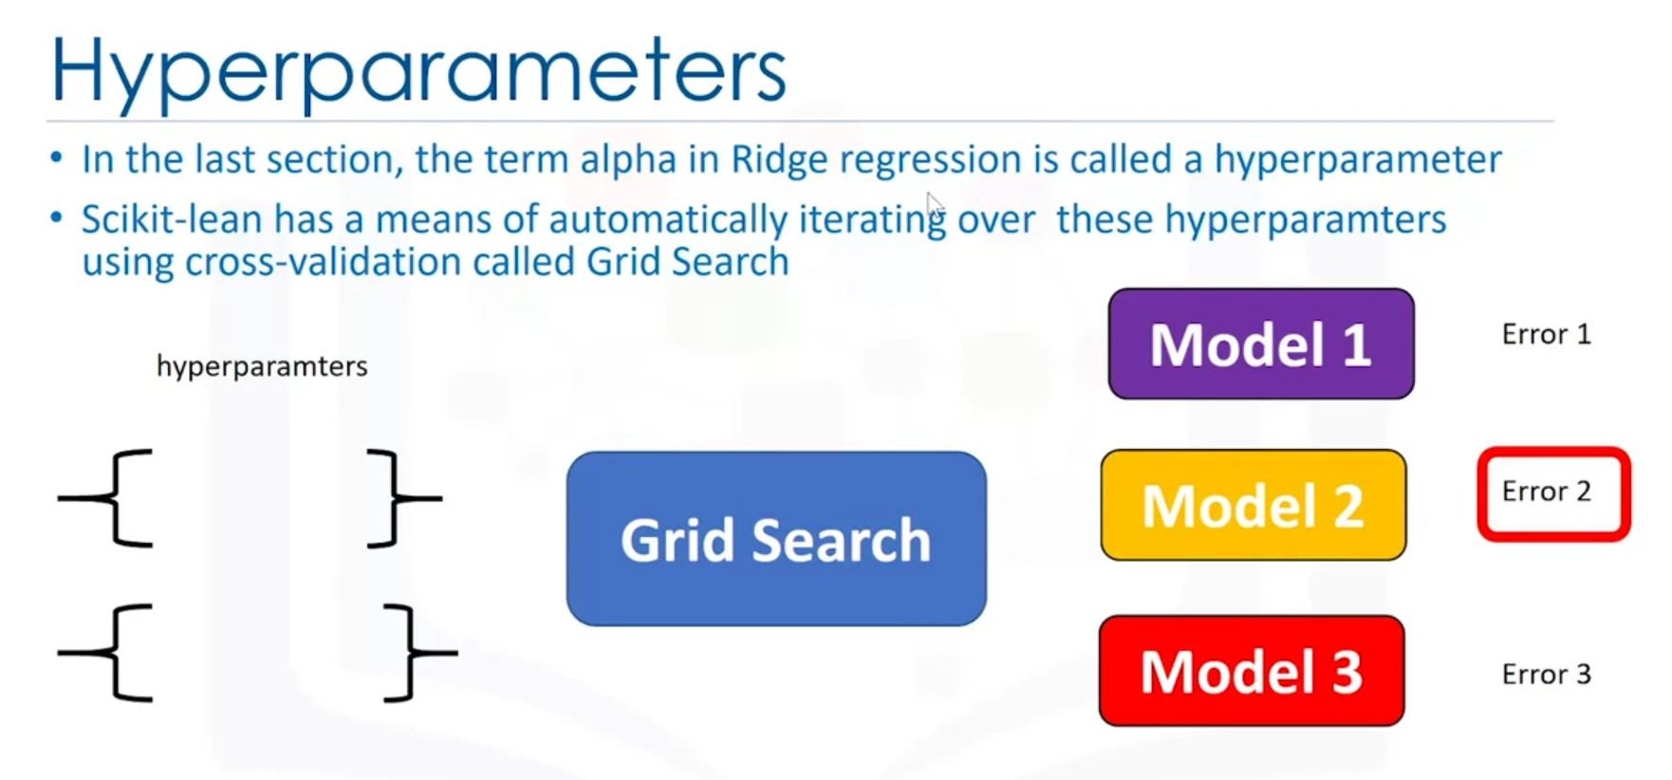

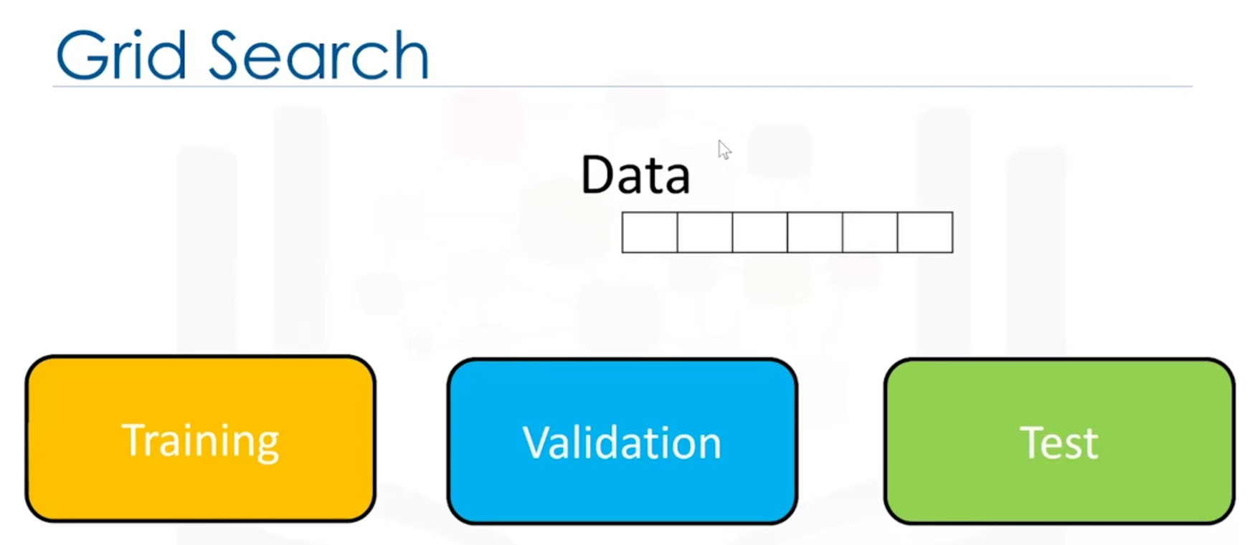

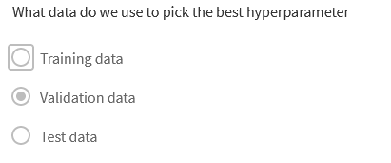

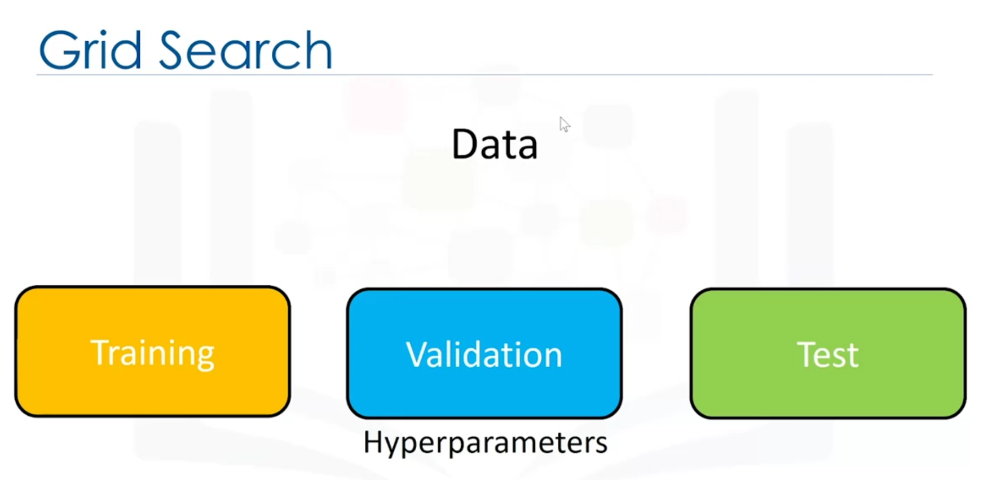

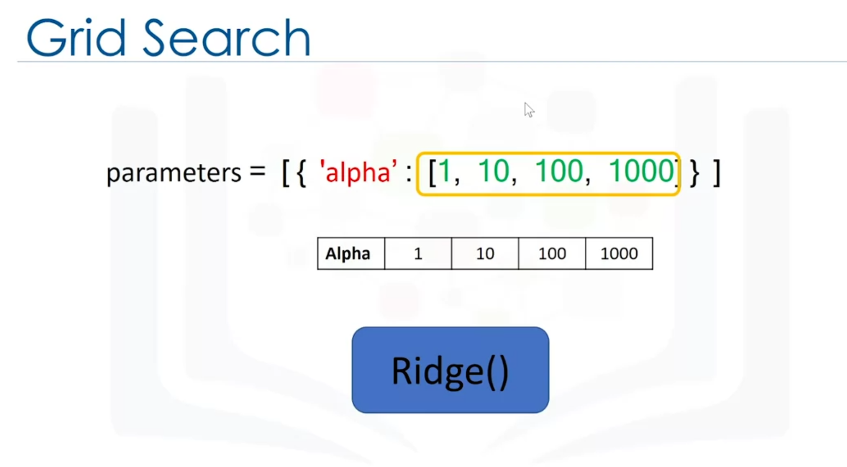

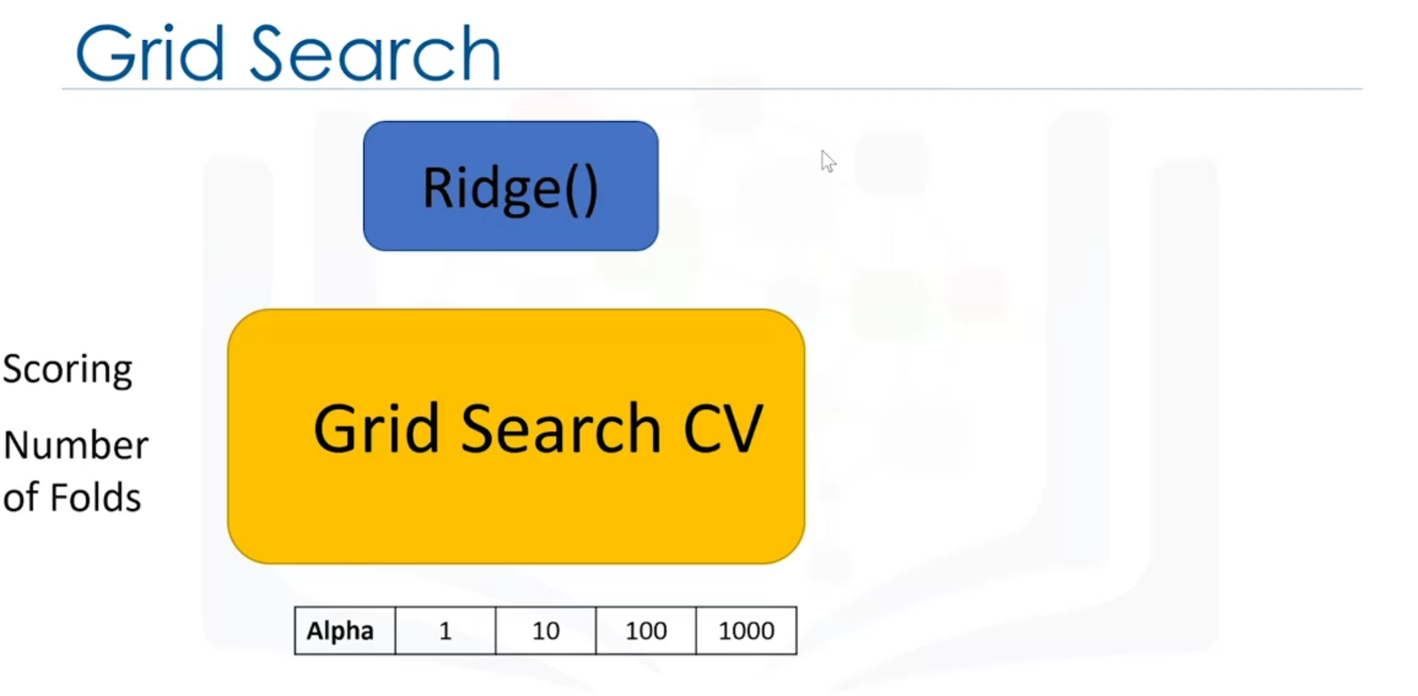

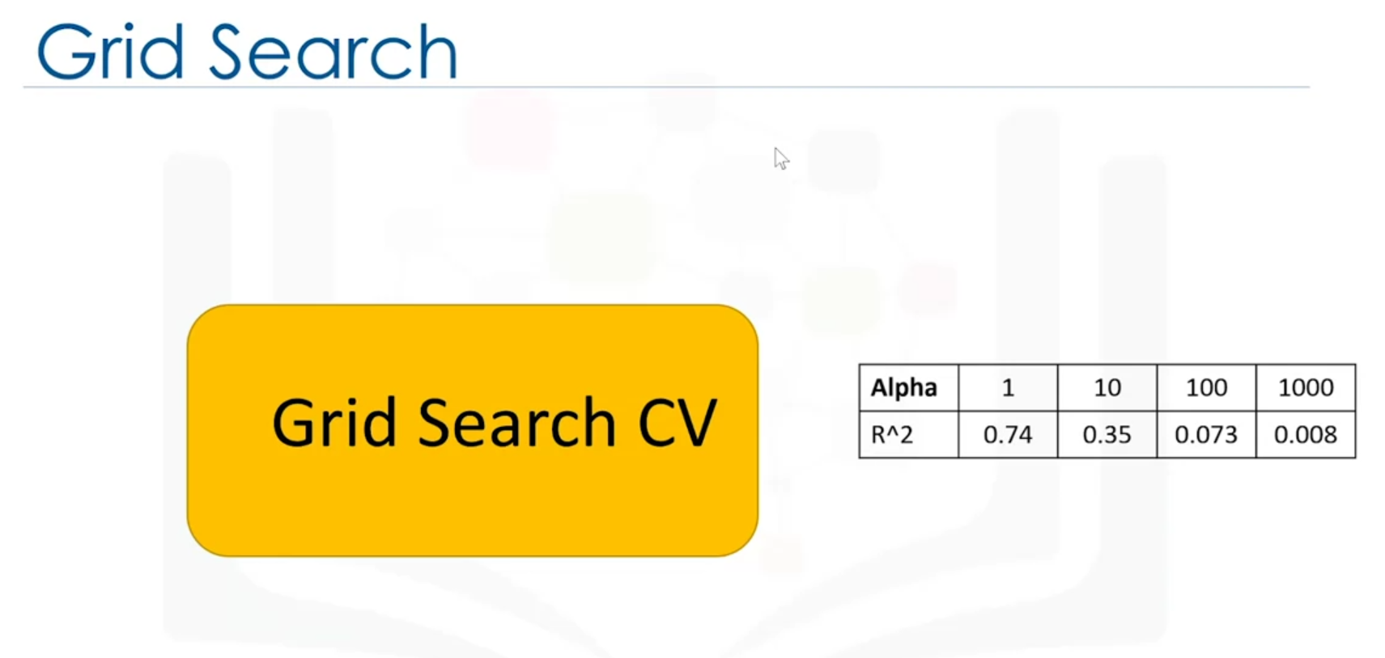

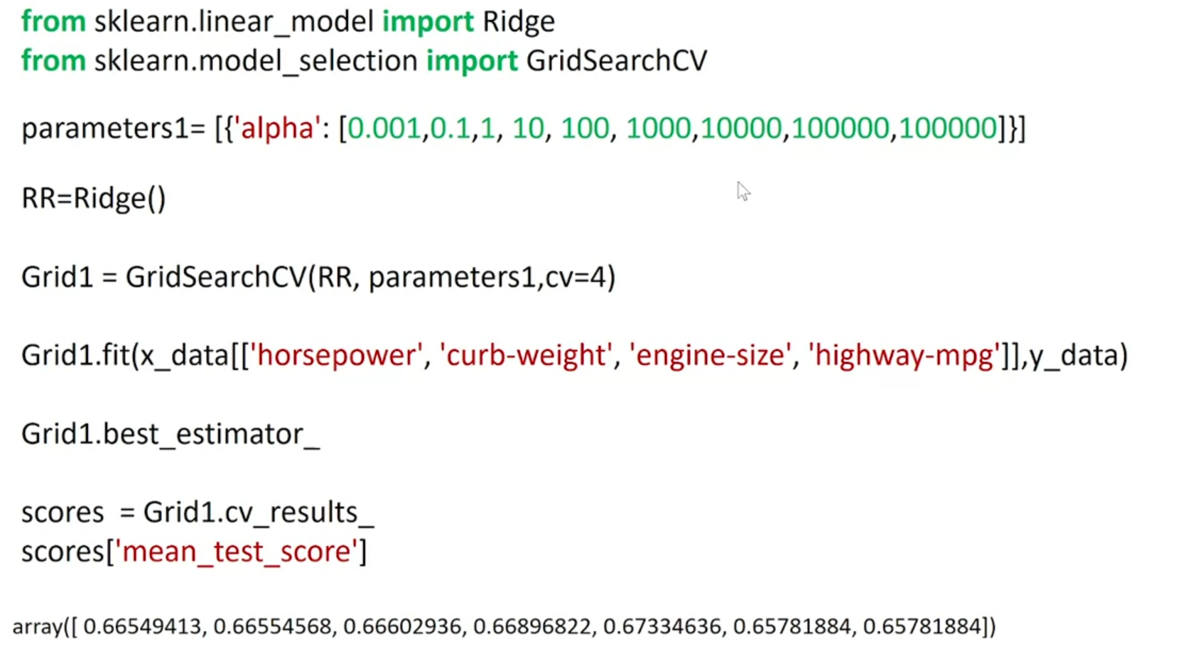

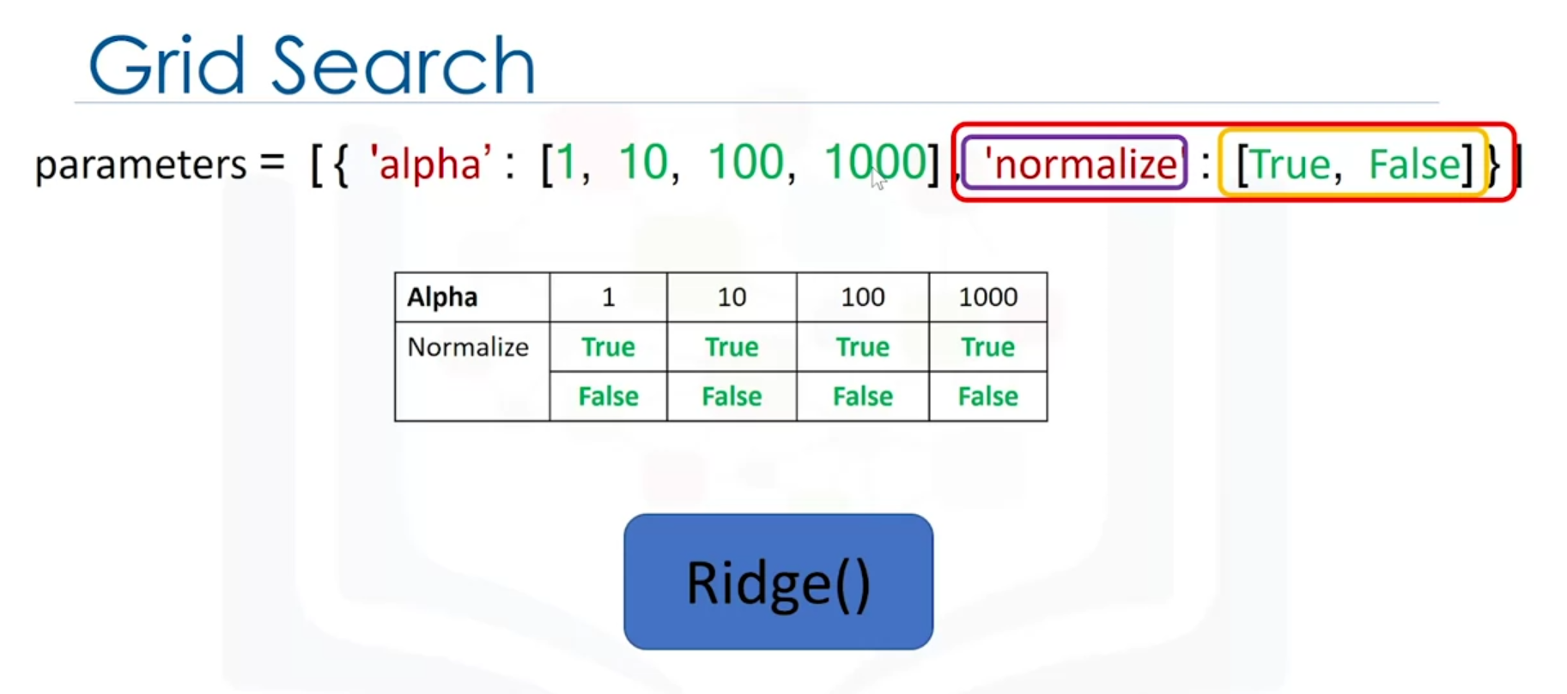

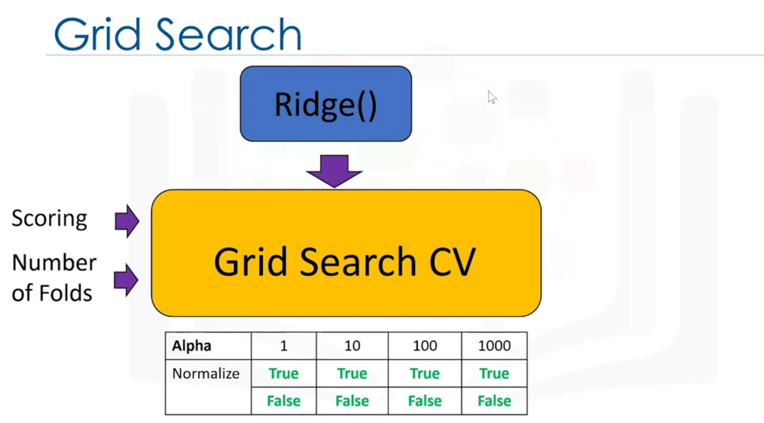

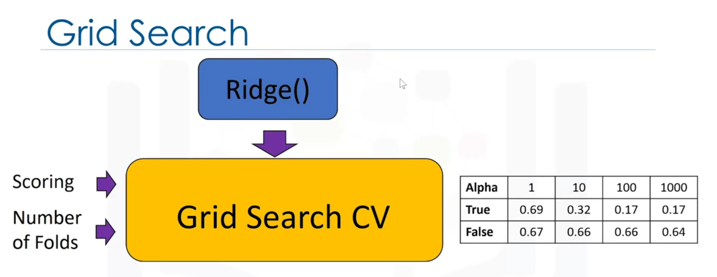

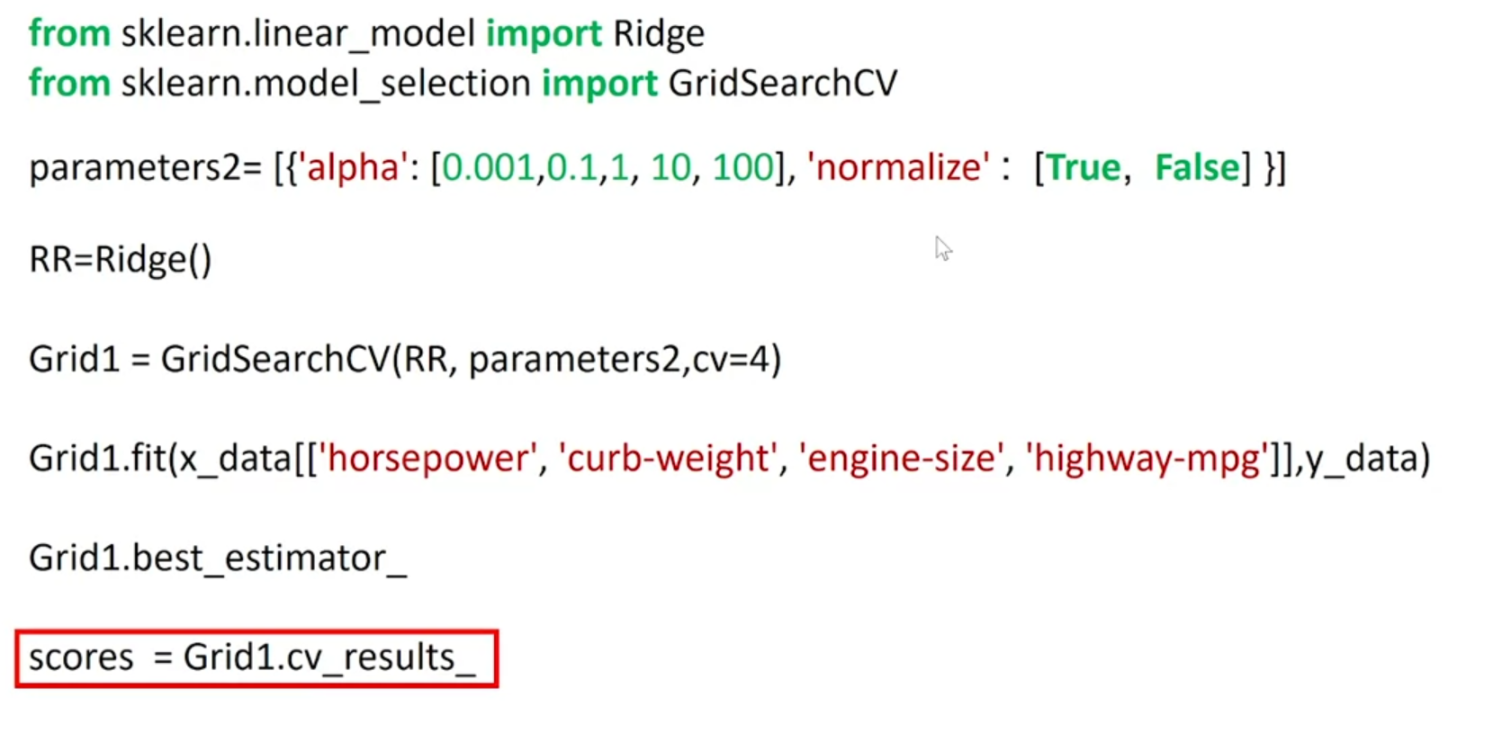

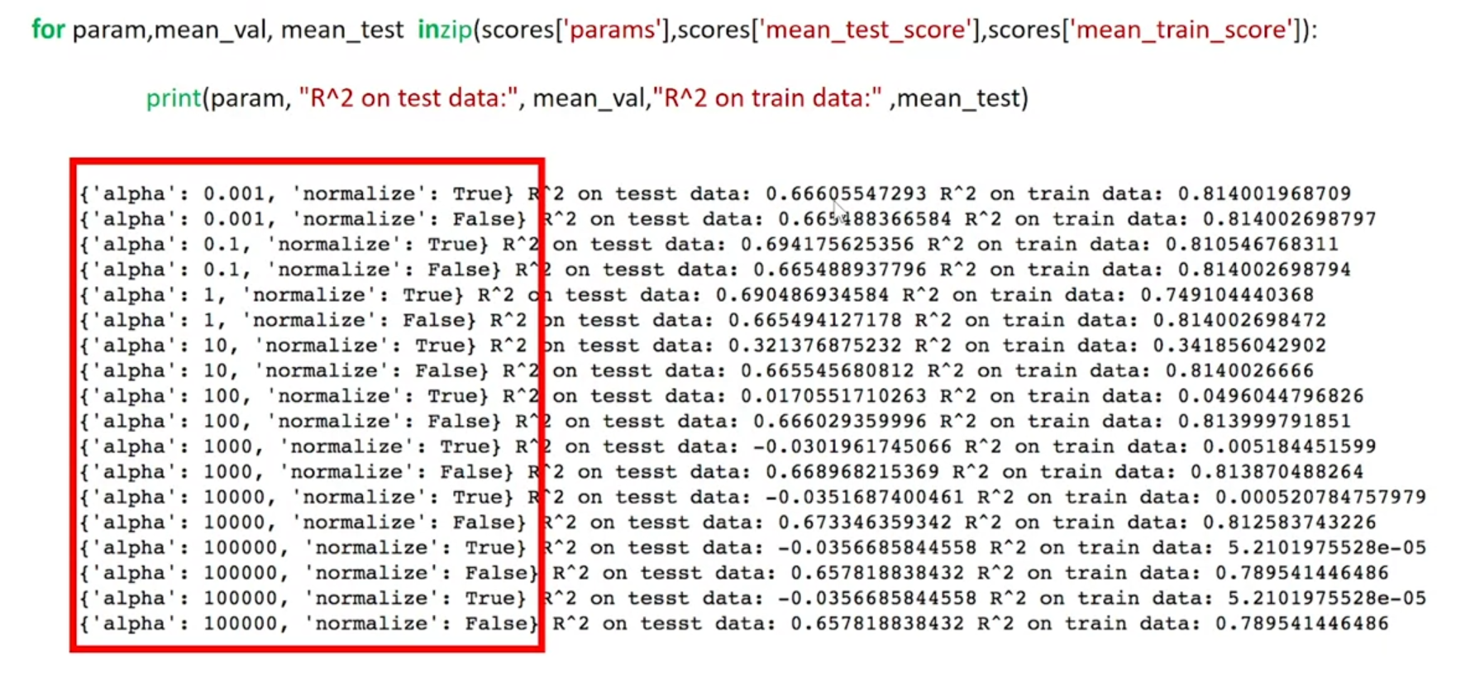

Correct answer is 2:

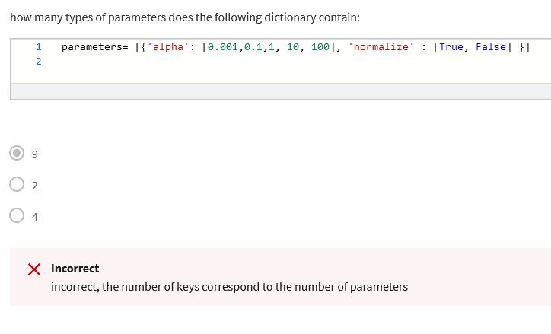

**Identify over-fitting and under-fitting in a predictive model:** Overfitting occurs when a function is too closely fit to the training data points and captures the noise of the data. Underfitting refers to a model that can't model the training data or capture the trend of the data.

**Apply Ridge Regression to linear regression models:** Ridge regression is a regression that is employed in a Multiple regression model when Multicollinearity occurs.

**Tune hyper-parameters of an estimator using Grid search:** Grid search is a time-efficient tuning technique that exhaustively computes the optimum values of hyperparameters performed on specific parameter values of estimators.

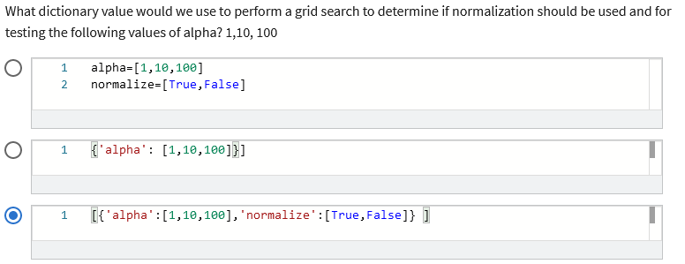

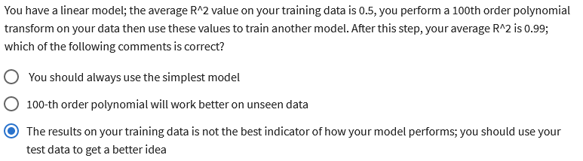

**Pandas drop + axis:**

I think this answer is the proper one. You need to visualize it. axis=0 (or axis='rows' is horizontal axis. axis=1 (or axis='columns') is vertical axis. To take it further, if you use pandas method drop, to remove columns or rows, if you specify axis=1 you will be removing columns. If you specify axis=0 you will be removing rows from dataset. So if we have some pandas dataframe in variable df: **df.drop(0, axis=0) will remove the whole first row of dataset** **df.drop('grades', axis=1) will remove column 'grades' from dataset** Hope this clarifies it little bit more...

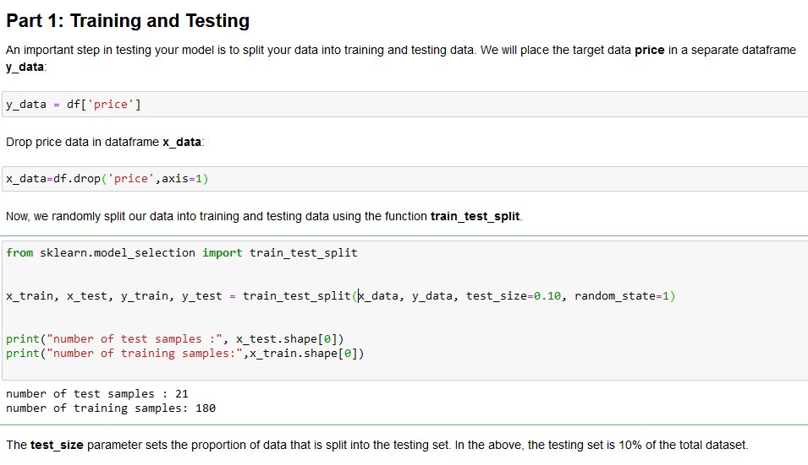

<https://scikit-learn.org/stable/modules/generated/sklearn.model_selection.train_test_split.html>